  - QF600 Asset Pricing · Group Project

Honey, the Fed Shrunk the Equity Premium: does it still hold, and what should an investor hold now?
Group 6 · Chew Junhong · Marcus Tan Jun Lin · Chia Chong Yee · Abirame d/o Asohan · Ramona Chia Ming Li
Submitted 03 November 2026

Executive Summary
Question. Do stocks earn less above cash when the risk-free rate is high, and what should an investor hold now that the 3-month T-bill pays 3.94%? We replicate Maloney (2024), "Honey, the Fed Shrunk the Equity Premium", test whether its result holds out of sample, and turn the evidence into strategies that we backtest.
The paper's result holds on its own sample. With free proxies for its data (1926–2023), stocks earned 11.1% a year above cash in the 12 months after lower-rate months and 5.4% after higher-rate months (paper: 10.3% and 5.8%). 4 of 6 tests (two horizons × three labelling rules) reject "rates make no difference" (H0), and we reproduce the paper's Exhibit 9 portfolios almost exactly.
It is much weaker as a forecast. Split in time, stocks still earned less after high rates in both 1926–1995 (10.7% vs 5.5%) and 1996–2026 (11.5% vs 5.8%), but only 2 of 6 tests are significant in each period, and a regression fitted on 1926–1995 forecasts 1996–2026 with an R² of just 0.15%. In 2024 and 2025 stocks beat cash by 18.9% and 12.8% despite high rates.
Our two challenges fail. Risk does not explain the gap: the equity Sharpe ratio is 0.59 after lower-rate months and 0.28 after higher-rate months (H2 rejected). A big government deficit does not offset high rates either (H3 rejected).
Backtests. On investable ETFs, judged only on December 2020 – September 2026, cutting stocks for bonds when rates are high did not pay. The paper's portfolios (Sharpe ratio 0.40), the rate rule (0.48) and 50/50 (0.35) all trail an equal-weight, never-rebalanced mix of stocks, Treasuries, gold and momentum (0.65). The one rule that beat it, ridge mean-variance tuned by walk-forward validation (0.81), moves into gold and momentum, not bonds, when rates are high; its edge is not significant (t = 1.31).
Recommendation. Being in the middle doesn't mean retreating to risk-free. Hold around 60% in stocks and, when rates are high, diversify the rest with gold and momentum rather than bonds alone. Since 1960, an equal mix of the four assets had a Sharpe ratio of 0.68 in higher-rate months, against 0.29 for 60/40.

1 Research Problem and Impact
From 2010 to 2021 the federal funds rate averaged about 0.5%; in 2022–23 it rose above 5%. Most forecasts put rates over the next decade about 3.2 percentage points higher than in the decade before (Maloney 2024, p.3). An investor who held 60% stocks and 40% bonds through the low-rate years now faces a simple question with a large impact on a portfolio: if cash and bonds pay more, should the stock share fall, and by how much?
We test the paper's answer, ask whether it still holds after 2023, and turn the result into allocations that an investor could actually run and that we backtest. Beating a benchmark is not the goal; an honest "no" is a valid result.

1.1 The paper and how it tests its claim
Maloney (2024, AQR Capital Management) asks whether the level of the cash rate should change asset allocation. It makes three claims (p.1): equities earned smaller returns above cash after periods of higher cash rates; private assets behaved like equities, while liquid alternatives that hold mostly cash earned about the same in both regimes; so in a higher-rate world, "cash-plus" strategies gain a relative advantage. It tests them in four steps.
Step | What the paper does | Page
1 Label months | Each month is "higher-rate" or "lower-rate" by comparing the 3-month T-bill rate with a cut-off, under three rules (§3.1). Rates below 0.5% always count as lower. | p.4, fn 4
2 Compare returns | Average return above cash over the next 1, 12 and 36 months after each type of month, averaged across the three rules (Exhibit 3 for 1926–2023; Exhibit 6 for 1990–2023). | p.5–10
3 Regressions | Next month's return above cash on today's T-bill rate (t = −2.2 for equities, −2.4 for credit), and a version that adds valuation, 1/CAPE (t = −3.2 and +3.9). The paper warns that these t-statistics overstate significance because rate levels persist. | p.5, p.7
4 Allocation | Maximum-Sharpe portfolios from assumed volatilities, Sharpe ratios and correlations, with a 3% real return target, for a lower- and a higher-rate world (Exhibit 9). They are illustrations; the paper does not backtest them. | p.12–13

The paper uses three sets of data:
Dataset | Period | Series and sources
Long | Monthly, Jan 1926 – Dec 2023 | 3-month T-bill (Federal Reserve from 1934, Global Financial Data before); US equity and Treasury returns (Global Financial Data); investment-grade credit returns over duration-matched Treasuries (Asvanunt and Richardson 2017); real earnings and CAPE (Shiller)
Broad | Monthly, Jan 1990 – Dec 2023 | Adds private equity, real estate, equity market-neutral and trend-following indices (Bloomberg and hedge-fund index providers); the rolling cut-off moves to the 30th percentile
Exhibit 9 inputs | Monthly, Jan 1990 – Jun 2023 | Volatilities and correlations from proxy data; Sharpe ratios assumed (about 0.3 for the main asset classes)

1.2 Our hypotheses
We fixed four hypotheses before looking at results, in two parts. Part A (H0 vs H1) replicates the paper; Part B (H2, H3) looks for evidence against its conclusion.
 | Hypothesis | Tested in
H0 | The T-bill rate level makes no difference: stocks earn the same above cash after higher- and lower-rate months. | §3.3–3.4
H1 | The paper's claim: after higher-rate months, stocks earn less above cash. | §3.3–3.4
H2 | Ours: once risk is counted, the gap is small; the equity Sharpe ratio after higher-rate months is not materially lower. | §3.5
H3 | Ours: a big government deficit keeps profits growing when rates are high, offsetting the penalty (Kalecki profits identity). | §4

2 Data
Global Financial Data (Finaeon), the paper's main source, is not available to us: SMU has no subscription and the free trial covers only US stocks from 2019. We use free proxies over the paper's sample (monthly, July 1926 – December 2023) and extend them to September 2026. All series are downloaded by the notebook (§1); Annex A lists every file with its source, size and columns.
Paper's series | Our proxy | Period
3-month T-bill rate (GFD before 1934) | FRED TB3MS from 1934; Ken French 1-month bill ×12 before | Jul 1926 – Sep 2026
US equity returns (GFD) | Ken French market return (CRSP, all US stocks) | Jul 1926 – Sep 2026
US Treasury returns (GFD) | 10-year bond return built from the 10-year yield (FRED GS10, Shiller before 1953) | Jul 1926 – Sep 2026
IG credit excess return | Baa bond return (Moody's Baa yield) minus the 10-year Treasury return | Jul 1926 – Sep 2026
Real earnings, CAPE | Robert Shiller's data library | 1871 – Oct 2026
Cash-plus / liquid alternatives | Momentum: T-bill + UMD (Ken French); PDP ETF in the backtest | 1927 – Sep 2026
(not in paper) gold | World Bank monthly gold price | Jan 1960 – Sep 2026
(not in paper) deficit | FRED federal surplus and interest outlays, % of GDP | 1929 / 1940 – 2025
Investable assets | SPY, IEF, GLD, PDP, PSP, HYG, VNQ, RSP (Yahoo Finance) | 2002 – Oct 2026

Our 10-year bond return, compounded to calendar years, has a correlation of 0.99 with Damodaran's published annual T-bond returns, so the proxy is close to a standard series.
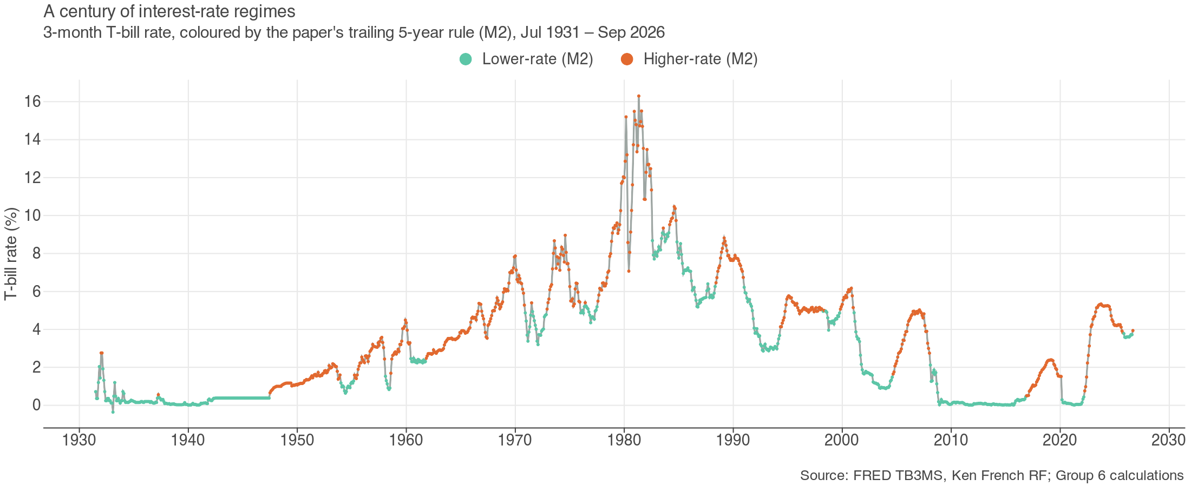
Figure 1: The 3-month T-bill rate and higher-rate months under the trailing 5-year rule (M2).

3 Replication of the Paper, In and Out of Sample

3.1 How months are labelled
Following the paper (p.4), each month is labelled higher- or lower-rate by comparing the 3-month T-bill rate with a cut-off. The three rules differ in which months set the cut-off:
Rule | Higher-rate if the T-bill rate is above… | Uses future data? | We use it for
M1 Full-sample median | the median of the whole sample (1926–2023) | Yes | Replication only
M2 Trailing 5 years | the 40th percentile of the previous 60 months | No | Replication and every strategy
M3 Centred 5 years | the 40th percentile of the 60 months centred on the month | Yes | Replication only

Under M2 and M3, rates below 0.5% always count as lower, and the cut-off is the 40th percentile rather than the median so that the two groups are about the same size (fn 4). December 2023 is higher-rate under all three rules, as in the paper (p.5). Unless stated otherwise, results are averaged across the three rules, as the paper does.

3.2 Exhibit 3: smaller premiums after higher rates
For every month we average the return above cash over the next 1, 12 and 36 months, then average across months and across the three rules. Our proxies reproduce the paper's equity gap at all three horizons. Credit shows an even larger gap. Treasuries differ: we find almost no penalty at 12 and 36 months, consistent with the paper's broad 1990–2023 sample, where Treasuries did slightly better after higher rates (p.7).
Asset · horizon | After lower (ours) | After higher (ours) | Paper lower / higher
Equities · 1M | 12.0% | 4.3% | 11.4% / 4.9%
Equities · 12M | 11.1% | 5.4% | 10.3% / 5.8%
Equities · 36M | 10.4% | 6.2% | 10.4% / 5.5%
Treasuries · 12M | 1.5% | 1.9% | 1.5% / 1.2%
IG credit · 12M | 4.0% | 0.2% | 2.6% / 1.1%
Momentum (UMD) · 12M | 4.0% | 9.9% | not reported
Annualised return above cash, Jul 1926 – Dec 2023, average of the three rules. Other horizons in Annex B.
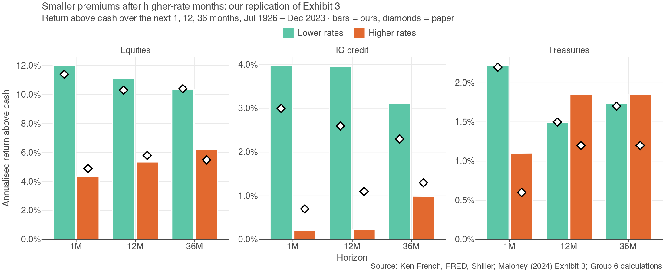
Figure 2: Our replication of Exhibit 3 (bars) against the paper's values (diamonds).

3.3 H0 against H1 on the paper's sample
We regress the equity return above cash over the next month (and the next 12 months) on a dummy that equals 1 after a higher-rate month. The slope is the gap between the two groups. Rate levels persist, so ordinary standard errors overstate significance (the paper's own caveat, p.5); we use Newey-West t-statistics and a one-sided 5% test: H0 is rejected in favour of H1 when t < −1.645.
Rule | Gap, next month | t | Gap, next 12 months | t
M1 Full-sample median | -3.9% | -1.01 | -5.9% | -2.01
M2 Trailing 5 years | -6.3% | -1.65 | -3.8% | -1.43
M3 Centred 5 years | -12.7% | -3.18 | -7.5% | -2.73
Gap = annualised return above cash after higher- minus after lower-rate months, Jul 1926 – Dec 2023. Newey-West t.
The paper's own test is a continuous regression of next month's return above cash on today's T-bill rate:
Asset | t on T-bill rate (OLS) | Newey-West t | Paper
Equities | -2.06 | -2.07 | −2.2
IG credit | -3.22 | -2.90 | −2.4
Treasuries | -0.30 | -0.17 | not significant
Monthly, Jul 1926 – Dec 2023.
All six gaps are negative and 4 of 6 tests reject H0. The rules that use the whole sample or future data (M1, M3) give the clearest gaps; the trailing rule M2, the only one an investor could have used at the time, rejects H0 at one month but not at twelve. The regression matches the paper: a significant negative slope for equities and credit, none for Treasuries. Result: on the paper's sample, H0 is rejected and H1 holds.

3.4 H0 against H1 in-sample (1926–1995) and out-of-sample (1996–2026)
A pattern found on the whole sample may not help an investor who only knows the past. We split the history in time order and repeat the test in each part: in-sample July 1926 – December 1995, out-of-sample January 1996 – September 2026. To keep the periods separate, M1's cut-off is the in-sample median, and each period's forward returns stay inside that period.
Rule | In-sample: lower / higher | Gap (t) | Out-of-sample: lower / higher | Gap (t)
M1 Median | 10.7% / 4.9% | -5.7% (-1.52) | 10.2% / 6.7% | -3.5% (-0.73)
M2 Trailing | 11.2% / 7.1% | -4.0% (-1.19) | 10.0% / 7.6% | -2.4% (-0.61)
M3 Centred | 10.3% / 4.6% | -5.7% (-1.80) | 14.2% / 3.1% | -11.2% (-2.14)
Tests rejecting H0 |  | 2 of 6 |  | 2 of 6
Annualised return above cash over the next 12 months; Newey-West t in brackets. "Tests rejecting H0" counts both horizons (1 and 12 months) and all three rules; one-month results in Annex B.
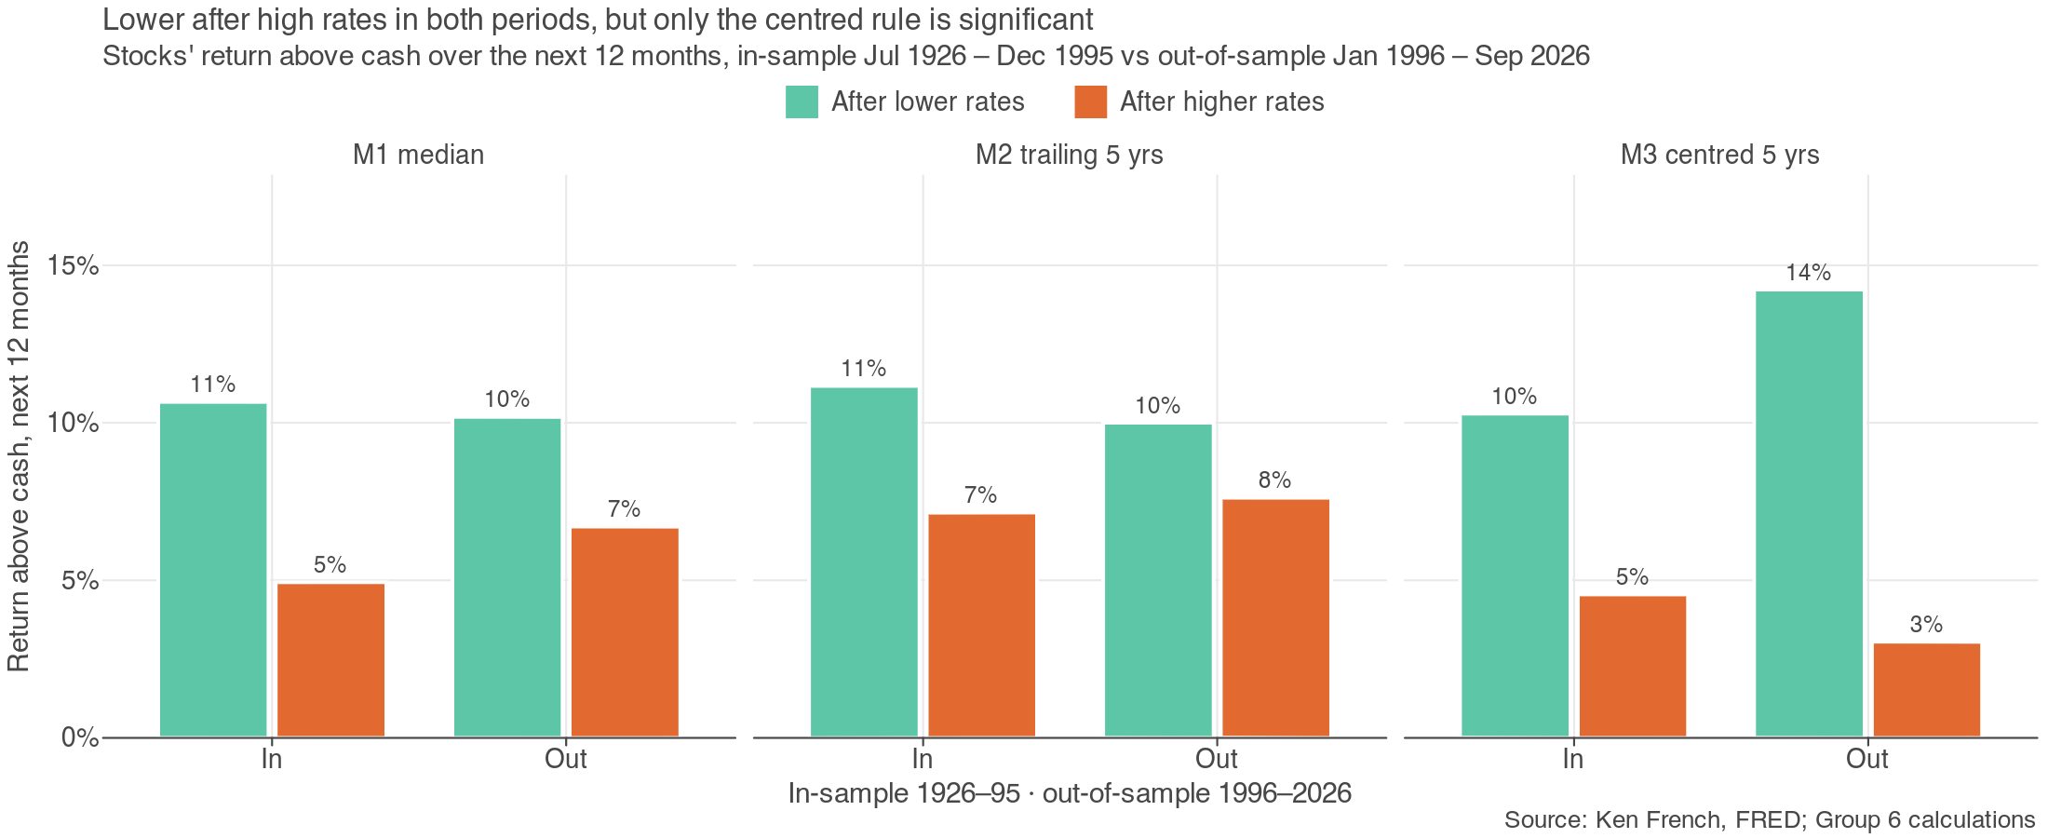
Figure 3: Return above cash after lower- and higher-rate months, in-sample and out-of-sample, by rule.
We also fit the paper's regression on the in-sample period only and use it to forecast the out-of-sample period. The out-of-sample R² compares its forecast errors with those of the in-sample average return (Campbell and Thompson 2008); above zero means the T-bill rate helps.
 | Fitted on 1926–1995 | Tested on 1996–2026
Slope: change in annual return above cash per 1 pp of T-bill rate | -1.30% (t = -1.82) | -1.05% (t = -0.79)
Out-of-sample R² | — | 0.15%

What this shows. The direction is stable: in both periods and under every rule, stocks earned less above cash after higher-rate months. The strength is not. Only 2 of 6 tests reject H0 in-sample and 2 of 6 out-of-sample, both times only under M3, the rule that uses future data. Under M2, the rule an investor could use, the 12-month gap is -4.0% in-sample and -2.4% out-of-sample, and significant in neither. The regression tells the same story: fitted on 1926–1995, it forecasts 1996–2026 barely better than the historical average. Result: H1 is right about the direction, but the rate level is a weak forecasting signal.

3.5 H2: the gap survives once risk is counted
If high-rate periods were simply calmer, a smaller premium could still pay the same per unit of risk. We compute the equity Sharpe ratio after each type of month (averaged over the three rules) and a 95% interval for the gap from a 12-month block bootstrap (2,000 draws), which keeps the persistence of rates.
Sample | After lower | After higher | Gap | 95% interval
Jul 1926 – Dec 2023 (paper: 0.57 / 0.31) | 0.59 | 0.28 | 0.32 | 0.00 to 0.75
Jul 1926 – Sep 2026 | 0.59 | 0.30 | 0.30 | -0.02 to 0.72
Annualised monthly Sharpe ratio of US equities.
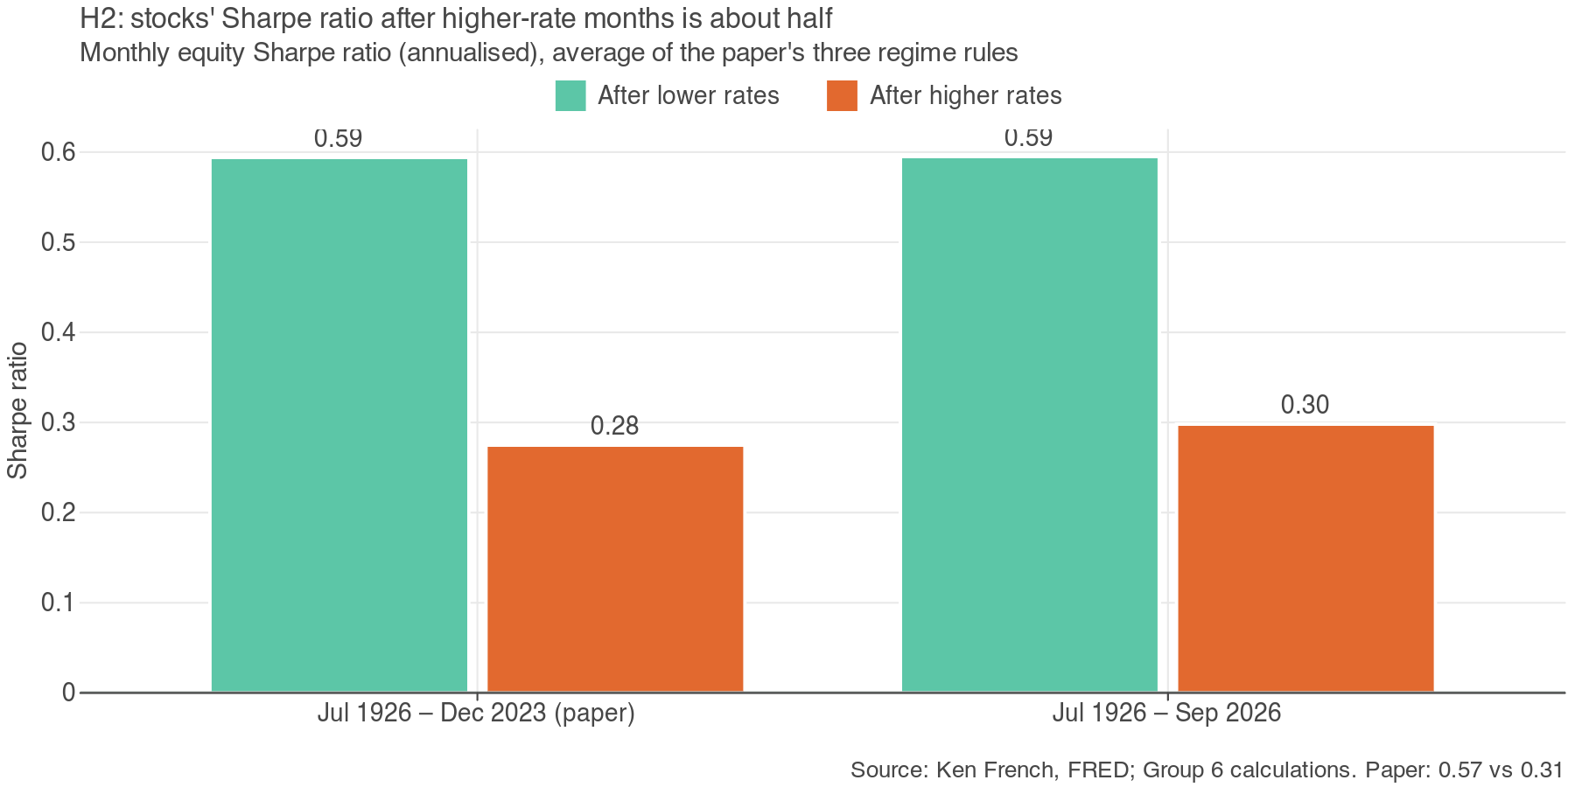
Figure 4: Equity Sharpe ratio after lower- and higher-rate months, paper sample and extended sample.
The Sharpe ratio roughly halves after higher-rate months, as in the paper. On the paper's sample the interval does not go below zero, so H2 is rejected: risk does not explain the gap. Adding 2024–26 leaves the gap almost unchanged but the interval now just includes zero: the recent years weaken the evidence without reversing it.

3.6 Momentum and Exhibit 9
Check | Ours | Paper
Momentum (UMD): extra return above cash after higher- vs lower-rate months | 7.9% (t = 2.61, M2) | About the same in both
Exhibit 9 implied Sharpe ratio, columns 1–4 | 0.45, 0.36, 0.44, 0.35 | 0.45, 0.36, 0.44, 0.35
Exhibit 9 weights: average absolute difference from the paper | 0.3% | —

Momentum, our stand-in for cash-plus strategies, did better than the paper claims: it earned more after higher-rate months, not the same. Exhibit 9, recomputed from the paper's assumptions (maximum-Sharpe long-only portfolios with a 3% real return target and real cash at −0.5% or +0.5%), matches the paper. Its lower- and higher-rate portfolios become strategy S1 in §6.

4 Why: Profits and the Deficit
The paper's explanation is fundamental: low rates stimulate demand and borrowing, so company earnings grow faster (p.7). Shiller's data confirm it.
Real earnings growth, per year | After lower-rate months | After higher-rate months
Ours (12- and 36-month horizons) | 13.9% | -1.2%
Paper | 11% | 1%

H3 asks whether a big government deficit breaks this link. Under the Kalecki profits identity, a deficit is income for households and firms, so it should support profits even when rates are high; this could explain 2024–25, when rates were high and the deficit near 6% of GDP. We split months by rate regime (M2) and by the primary deficit (deficit excluding interest, above or below its median to date, used from the January after each fiscal year).
Next-12-month return above cash | Small deficit | Big deficit
After lower-rate months | 7.8% | 10.9%
After higher-rate months | 10.1% | 5.4%
1941 – 2026, M2 rule. Primary deficit = federal deficit minus interest outlays, % of GDP (FRED).
After higher-rate months: big minus small deficit | Difference | Newey-West t
Next-12-month return above cash | -4.7% | -1.30
Next-12-month real earnings growth | 1.2% | 0.31

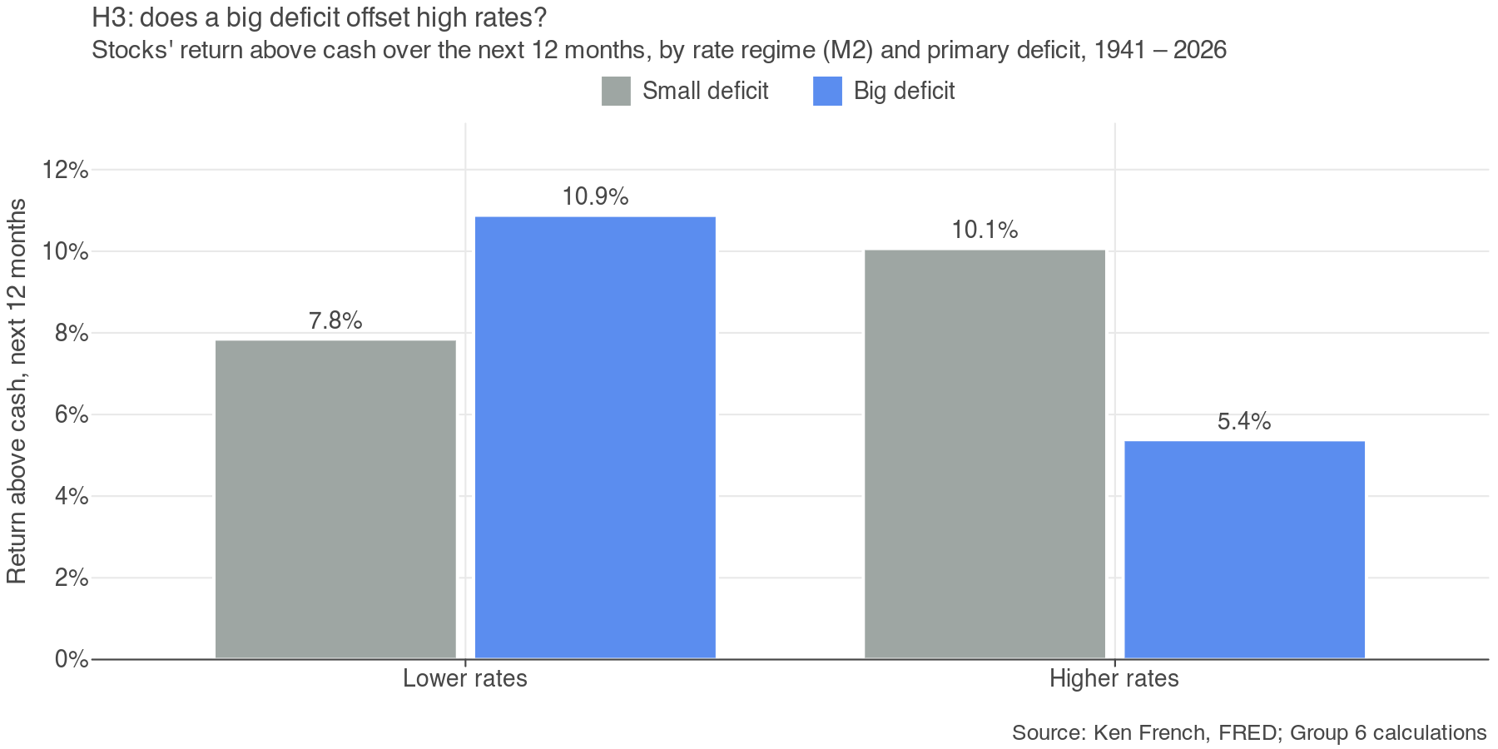
Figure 5: Stocks' next-12-month return above cash by rate regime and primary deficit.
The offset is not there. After higher-rate months, stocks did worse, not better, when the deficit was big, and earnings grew no faster; neither difference is significant. H3 is rejected: the deficit does not explain why stocks did well in 2024–25, and the paper's explanation stands.

5 Does It Still Hold? Recent Years and Robustness
§3.4 showed the signal is weak out of sample. Here we look at the most recent high-rate years and check the result with a simpler rule and a valuation control.
Year | Stocks' return above cash | S&P 500 cap-weight minus equal-weight
2023 | — | +12.5%
2024 | 18.9% | +12.1%
2025 | 12.8% | +6.5%
2026 (Jan–Sep) | 9.0% | —
Average after higher-rate months, 1926–2023 | 7.0% | —
Calendar-year returns. Cap-weight = SPY, equal-weight = RSP.
The recent years break the pattern: stocks beat cash by far more than the historical average after higher-rate months. The deficit is not the reason (§4). Concentration is: the cap-weighted S&P 500 beat its equal-weight version by a wide margin in 2023 and 2024, so the gains came from a few very large companies. Valuation also rose: CAPE is now 40.7, near its historical high.
Robustness check | Ours | Paper
Simpler rule (rate above its own 5-year average): next-12-month return above cash, after lower / higher | 10.6% / 6.8% | —
Two-factor regression: t on the T-bill rate | -3.15 | −3.2
Two-factor regression: t on 1/CAPE (valuation) | 4.03 | +3.9
Jul 1926 – Dec 2023, OLS t-statistics as in the paper.
Both checks agree with the paper: a simpler rule gives the same direction, and controlling for valuation makes the rate effect stronger. With CAPE near 40 and rates high, the two-factor model predicted a low premium for 2024–25, which is exactly what did not happen.
Verdict on the paper: partly true. The relationship is real over a century, reproduces closely and keeps its direction out of sample, but it is too weak to forecast with, and it failed in the most recent high-rate episode.

6 What Should an Investor Hold? From Findings to Backtested Strategies
We turn the findings into allocations in two steps. First, the longest history available (monthly, February 1960 – September 2026, with stocks, 10-year Treasuries, gold and momentum) shows which assets protect a portfolio when rates are high and how large the stock share should be. Second, each finding becomes a strategy, and all strategies are backtested on investable ETFs and judged only on data they never saw.

6.1 Evidence from 66 years of data
Correlation with stocks | Higher-rate months | Rates rising
Bonds (10-year Treasuries) | 0.22 | 0.28
Gold | 0.00 | 0.02
Momentum (T-bill + UMD) | -0.08 | 0.05
Monthly, Feb 1960 – Sep 2026. Rising = 12-month change in the T-bill rate above +0.5 percentage points. Gold was fixed at $35 until Aug 1971.
Sharpe ratio (CVaR 5%) | 60/40 | 50/50 | 1/N: stocks, bonds, gold, momentum
Higher-rate months | 0.29 (5.8%) | 0.28 (5.0%) | 0.68 (3.5%)
Rates rising | -0.03 (6.5%) | -0.04 (5.7%) | 0.38 (4.3%)
Rates falling | 0.88 (5.1%) | 0.90 (4.2%) | 1.03 (3.0%)
Monthly rebalancing. CVaR 5% = average loss in the worst 5% of months. Falling = 12-month change below −0.5 percentage points.
How much in stocks? | Stock share
Mean-variance w* = (E[R] − r_f) / (Aσ²), A = 3, after lower-rate months | 144%
Mean-variance w*, after higher-rate months | 66%
Best stock/bond mix by Sharpe, today's T-bill third (middle) | 100%
Best mix, today's valuation third (bad: stocks expensive) | 30%
Best mix, today's deficit third (good: big deficit) | 60%
Recommended: average of the last four rows, rounded to 10% | 60%
Thirds use cut-offs from the whole sample, so they describe history rather than form a trading rule. Valuation gap = 1/CAPE minus the real 10-year yield.
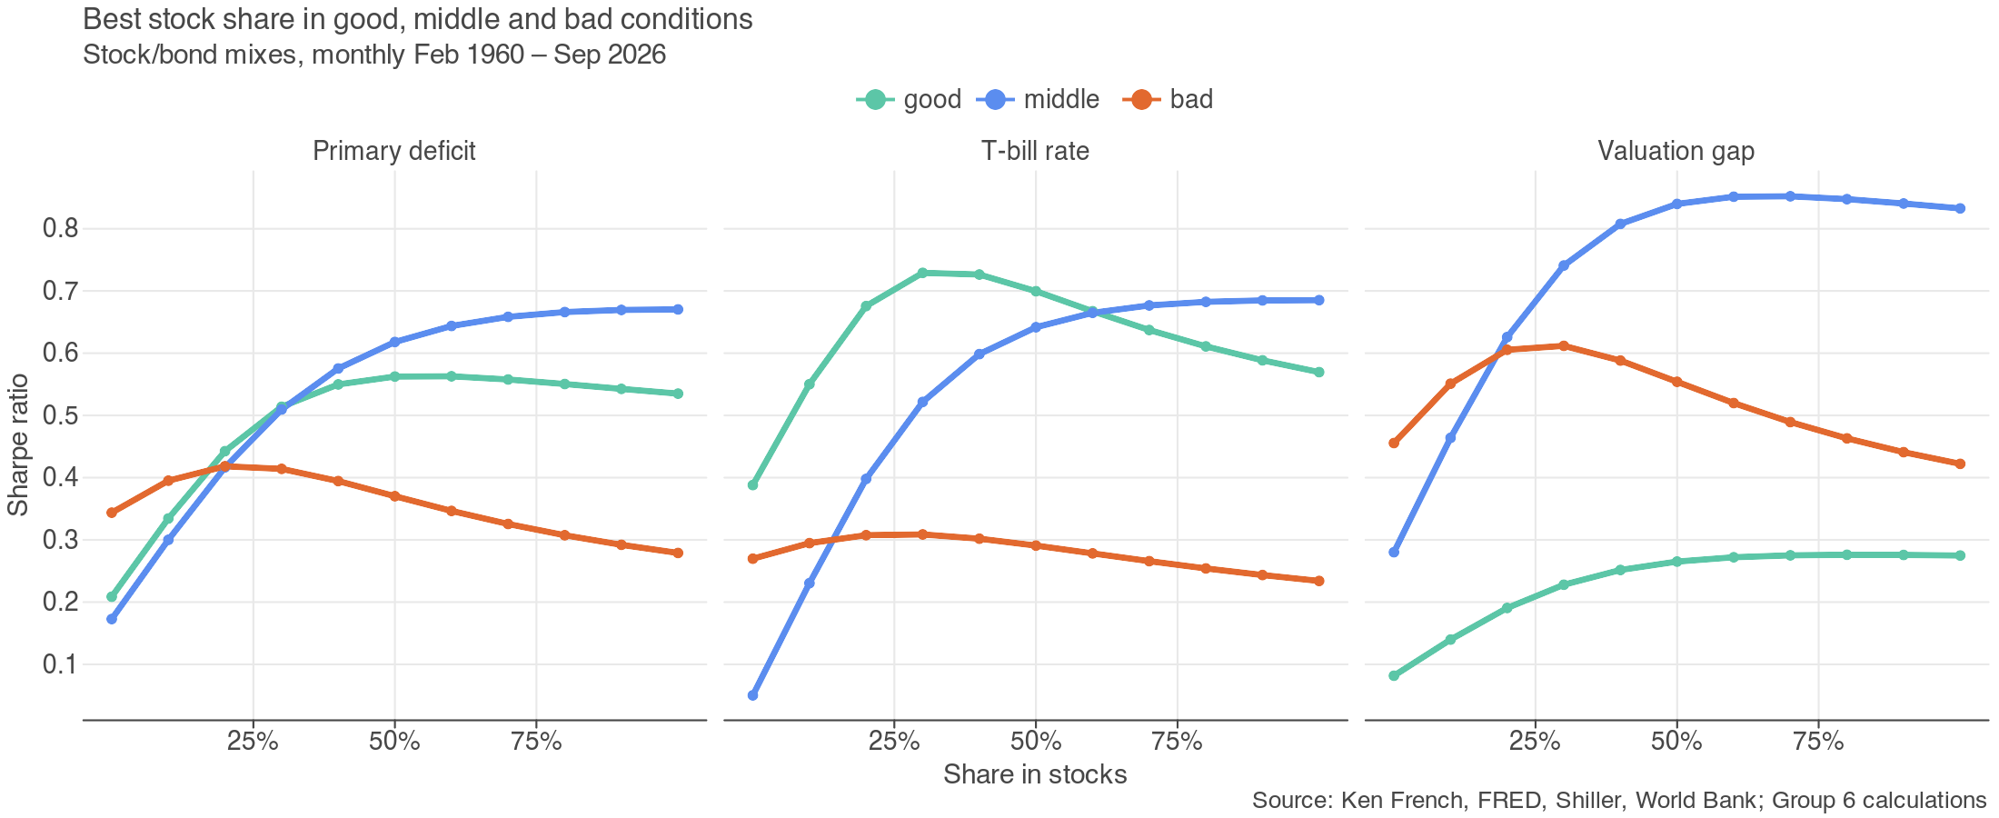
Figure 6: Sharpe ratio of stock/bond mixes by stock share, in good, middle and bad thirds of each variable.
Three findings come out. First, bonds are a weaker cushion when rates are high or rising: their correlation with stocks turns positive, as in 2022 when both fell, while gold and momentum stay close to uncorrelated. Second, moving from 60/40 to 50/50 lowers tail risk but not the Sharpe ratio; adding gold and momentum (1/N) more than doubles the Sharpe ratio of 60/40 in higher-rate months and keeps it positive while rates rise. Third, the stock share should fall after higher-rate months, but not to zero: mean-variance (Lecture 2) cuts it because the premium roughly halves while volatility barely changes, and the good / middle / bad split of history points to the same range today.

6.2 From findings to strategies
Each strategy tests one finding. All use the trailing rule M2 at the end of the previous month, so they only use information available at the time.
Code | Rule | Finding it tests
B Benchmark | Equal amounts in SPY, IEF, GLD, PDP, bought once and never rebalanced; restarted at equal weights in each period | Simple diversification
S1 Paper | Low rates: 37 SPY / 17 PSP / 18 IEF / 10 VNQ / 19 PDP; high: 26 SPY / 10 PSP / 33 IEF / 3 HYG / 28 PDP | The paper's allocation advice (Exhibit 9)
S2 Rate rule | 70% SPY / 30% IEF when rates are low; 50/50 when high | Smaller premium after high rates (H1, w*)
100/0 to 50/50 | Fixed mixes: 100%, 70%, 60% or 50% SPY, the rest IEF | Typical portfolios; is 50/50 better than 60/40?
1/N | 25% each in SPY, IEF, GLD, PDP, rebalanced monthly | Diversifiers (§6.1)
S3 Rate + deficit | As S2, but 60/40 when rates are high and the primary deficit is big | Deficit offset (H3)
S4 Ridge MV | w = (λΣ + ηI)⁻¹μ on SPY, IEF, GLD, PDP, estimated for each regime, long-only (Lecture 5) | Bonds protect less, gold and momentum more, when rates are high

6.3 How we backtest
ETFs: SPY (stocks), IEF (7–10-year Treasuries), GLD (gold) and PDP (momentum), plus PSP (listed private equity), HYG (high yield) and VNQ (real estate) for S1. The sample runs monthly from May 2007, when every fund exists, to September 2026 and is split in time order: everything is chosen or fitted on the first 70% (May 2007 – November 2020, in-sample) and judged only on the last 30% (December 2020 – September 2026, out-of-sample), which contains the 2022–26 high-rate period. Strategies rebalance monthly and pay 10 basis points per unit of turnover. Alpha and beta come from regressing each strategy's monthly excess return on the benchmark's, with Newey-West t-statistics.
Choosing S4's ridge penalty η without flattering it. Picking η by the Sharpe ratio over the whole in-sample period lets the same months both fit the weights and judge them: that gave η = 0.01 and an in-sample Sharpe ratio of 1.17, which fell to 0.47 out of sample. We use walk-forward validation inside the in-sample period instead:
- Train on an expanding window that starts with ten years (May 2007 – April 2017) and estimate μ and Σ for each regime.
- Score each candidate η by the Sharpe ratio of the next 12 months (the validation window), after costs.
- Roll forward a year and repeat: 4 validation windows, the last one the 7 months before the out-of-sample period.
- Pick the η with the highest average validation Sharpe, refit the weights on the full in-sample period, and test once on the untouched out-of-sample period.
The ridge formula, regime rule and constraints (long-only, fully invested) are unchanged. A regime needs at least 24 higher-rate months in the training window; otherwise the lower-rate weights are used in both (true only in the first window).
η | 0.01 | 0.05 | 0.1 | 0.5 | 1 | 2 | 5 | 10 | 20
Average validation Sharpe | 1.13 | 1.22 | 1.26 | 1.29 | 1.29 | 1.29 | 1.29 | 1.29 | 1.29

Final S4 weights | SPY | IEF | GLD | PDP
Lower-rate months | 38% | 12% | 13% | 37%
Higher-rate months | 7% | 23% | 54% | 17%
Fitted on May 2007 – Nov 2020 with η = 20.
Validation Sharpe rises with η up to 0.5 and is flat after that, because stronger shrinkage stops changing the weights; the highest average is at η = 20. The tuned S4 is heavily diversified: when rates are high it holds mostly gold, Treasuries and momentum rather than stocks.

6.4 The paper's strategies on their own
We first judge the paper's own advice (S1) and the simplest rule in its direction (S2) against the benchmark.
Metric | B in | B out | S1 in | S1 out | S2 in | S2 out
Alpha (annual, vs B) | — | — | 0.51% | -2.28% | 2.55% | -0.90%
Alpha t-stat (Newey-West) | — | — | 0.16 | -0.86 | 1.31 | -0.39
Beta (vs B) | — | — | 1.03 | 1.02 | 0.75 | 0.81
Annual return | 7.8% | 10.4% | 8.0% | 7.8% | 8.6% | 8.0%
Annual volatility | 9.8% | 11.6% | 14.0% | 13.2% | 9.8% | 10.6%
Annual variance | 0.0096 | 0.0135 | 0.0195 | 0.0174 | 0.0097 | 0.0113
Sharpe ratio | 0.74 | 0.65 | 0.57 | 0.40 | 0.81 | 0.48
CVaR 5% (monthly) | 5.8% | 6.4% | 9.8% | 7.6% | 6.2% | 5.8%
Max drawdown | -22.2% | -20.0% | -49.0% | -24.8% | -32.7% | -20.2%
Turnover (per year) | 0.00 | 0.00 | 0.44 | 0.41 | 0.38 | 0.31
In = May 2007 – Nov 2020 (in-sample); out = Dec 2020 – Sep 2026 (out-of-sample). After 10 bps trading costs.
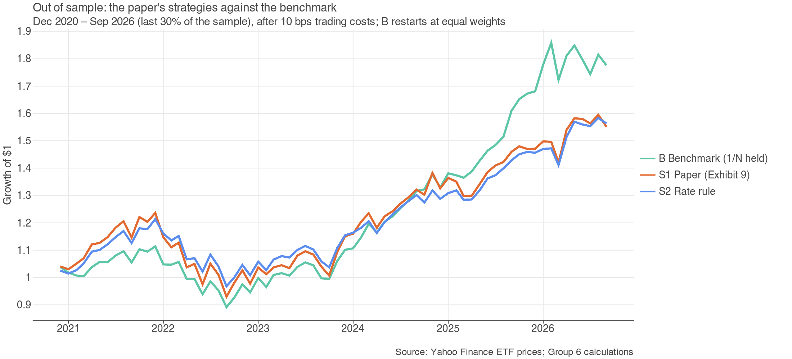
Figure 7: Growth of $1 out of sample (Dec 2020 – Sep 2026): the paper's strategies against the benchmark, after trading costs.
In-sample, the rate rule S2 has a higher Sharpe ratio than the benchmark (0.81 vs 0.74). Out of sample, both of the paper's strategies fall behind. S1 has the lowest Sharpe ratio (0.40) and the deepest drawdown, because private equity and real estate behaved like leveraged stocks (beta 1.02). S2 (0.48) cut stocks to 50% just before the 2023–25 rally. Neither alpha is significant. Followed directly, the paper's advice would have lagged simple diversification in the very period it was written for.

6.5 All strategies compared
Out-of-sample, Dec 2020 – Sep 2026
Strategy | Alpha | t | Beta | Return | Vol. | Var. | Sharpe | CVaR 5% | Max DD | Turn.
B Benchmark | — | — | — | 10.4% | 11.6% | 0.0135 | 0.65 | 6.4% | -20.0% | 0.00
S1 Paper | -2.28% | -0.86 | 1.02 | 7.8% | 13.2% | 0.0174 | 0.40 | 7.6% | -24.8% | 0.41
S2 Rate rule | -0.90% | -0.39 | 0.81 | 8.0% | 10.6% | 0.0113 | 0.48 | 5.8% | -20.2% | 0.31
100/0 | 4.02% | 1.19 | 1.10 | 15.2% | 15.0% | 0.0224 | 0.82 | 8.0% | -23.9% | 0.00
70/30 | 0.28% | 0.12 | 0.90 | 9.8% | 11.8% | 0.0138 | 0.59 | 6.5% | -21.4% | 0.16
60/40 | -0.96% | -0.47 | 0.83 | 8.0% | 10.8% | 0.0116 | 0.49 | 5.9% | -20.5% | 0.18
50/50 | -2.20% | -1.22 | 0.76 | 6.3% | 9.9% | 0.0097 | 0.35 | 5.5% | -19.7% | 0.19
1/N rebal. | -0.28% | -0.66 | 0.95 | 9.7% | 11.1% | 0.0122 | 0.62 | 6.0% | -19.3% | 0.30
S3 Rate + deficit | -0.31% | -0.13 | 0.85 | 8.9% | 11.2% | 0.0124 | 0.54 | 6.1% | -20.8% | 0.23
S4 Ridge MV | 2.69% | 1.31 | 0.88 | 12.3% | 11.5% | 0.0133 | 0.81 | 6.3% | -22.6% | 0.62

In-sample, May 2007 – Nov 2020
Strategy | Alpha | t | Beta | Return | Vol. | Var. | Sharpe | CVaR 5% | Max DD | Turn.
B Benchmark | — | — | — | 7.8% | 9.8% | 0.0096 | 0.74 | 5.8% | -22.2% | 0.00
S1 Paper | 0.51% | 0.16 | 1.03 | 8.0% | 14.0% | 0.0195 | 0.57 | 9.8% | -49.0% | 0.44
S2 Rate rule | 2.55% | 1.31 | 0.75 | 8.6% | 9.8% | 0.0097 | 0.81 | 6.2% | -32.7% | 0.38
100/0 | 0.93% | 0.27 | 1.12 | 9.0% | 15.7% | 0.0246 | 0.58 | 10.0% | -50.8% | 0.07
70/30 | 1.82% | 0.88 | 0.81 | 8.2% | 10.5% | 0.0111 | 0.73 | 6.8% | -35.4% | 0.28
60/40 | 2.12% | 1.29 | 0.71 | 7.9% | 8.9% | 0.0079 | 0.82 | 5.8% | -29.5% | 0.31
50/50 | 2.42% | 1.92 | 0.61 | 7.6% | 7.4% | 0.0055 | 0.92 | 4.8% | -23.1% | 0.32
1/N rebal. | 0.83% | 1.03 | 0.95 | 8.4% | 9.6% | 0.0093 | 0.81 | 5.7% | -25.7% | 0.38
S3 Rate + deficit | 2.20% | 1.11 | 0.78 | 8.4% | 10.1% | 0.0103 | 0.78 | 6.4% | -33.7% | 0.38
S4 Ridge MV | 3.00% | 1.24 | 0.98 | 10.7% | 11.8% | 0.0140 | 0.86 | 7.1% | -39.0% | 0.53

Alpha (annualised) and beta from regressing monthly excess returns on the benchmark B's, Newey-West t. Vol. = annual volatility; Var. = annual variance; CVaR 5% = average monthly loss in the worst 5% of months; Turn. = turnover per year. After 10 bps trading costs.
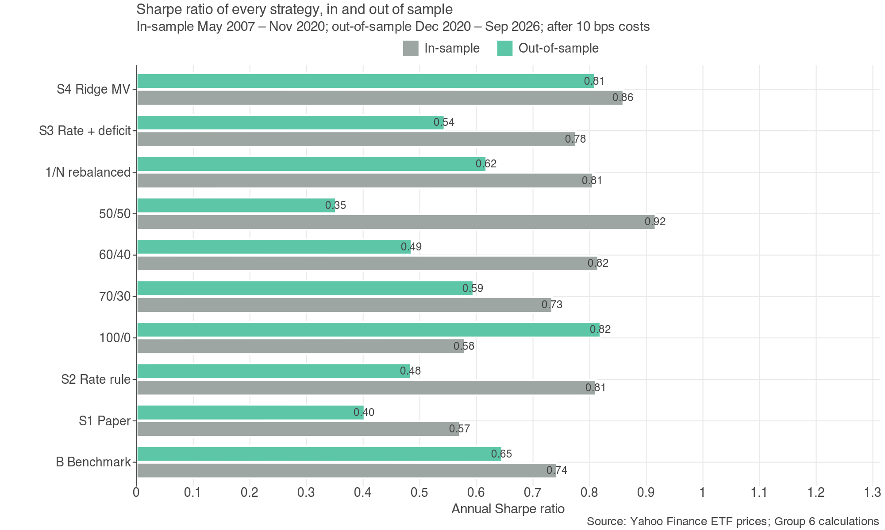
Figure 8: Sharpe ratio of every strategy, in-sample and out-of-sample.
Four points stand out.
- Fixed stock/bond mixes do not travel. In-sample, the lower the stock share the better the Sharpe ratio (50/50 best at 0.92); out of sample the order reverses (100/0 best at 0.82, 50/50 worst at 0.35). Moving from 60/40 to 50/50 when rates rise is not a reliable improvement.
- Timing the stock share by rates loses to doing nothing. S2 and S3 trail the benchmark out of sample with negative, insignificant alphas; the deficit filter in S3 helps only a little.
- Changing the diversifiers by regime is the one rule that helped. S4, which moves into gold and momentum when rates are high, has the largest alpha (2.69%) and a Sharpe ratio of 0.81. The alpha is not significant (t = 1.31), owes much to gold's 2024–26 rally, and S4 trades the most (turnover 0.62 a year).
- Simple diversification is hard to beat. Only 2 of the 9 strategies beat the never-rebalanced benchmark's out-of-sample Sharpe ratio (0.65): S4, and 100% stocks, which rode the large-company rally (§5).

6.6 The next ten years: rates stay high or fall
We simulate 2,000 ten-year paths. Rates switch between regimes with probabilities counted from history (Pun, Wang and Yan, p.17): a higher-rate month is followed by another 96.7% of the time. Each simulated month draws a historical month (1960–2026) from the same regime, using the long-history stand-ins for the ETFs. S1 is left out because its assets have no long history.
Strategy | Rates stay high | Rates fall | Always high (stress)
B Benchmark | 9.8% (5.9%) | 9.5% (5.7%) | 11.1% (6.9%)
S2 Rate rule | 9.3% (3.7%) | 9.6% (3.8%) | 7.8% (2.9%)
S3 Rate + deficit | 9.5% (3.5%) | 9.7% (3.7%) | 8.1% (2.7%)
S4 Ridge MV | 9.4% (4.7%) | 9.4% (4.8%) | 9.6% (4.5%)
60/40 | 9.2% (3.7%) | 9.4% (3.8%) | 8.1% (2.7%)
50/50 | 8.7% (3.9%) | 8.9% (4.0%) | 7.8% (2.9%)
Annualised 10-year return: median across paths, with the worst 5% of paths in brackets. Monthly rebalancing, no costs.
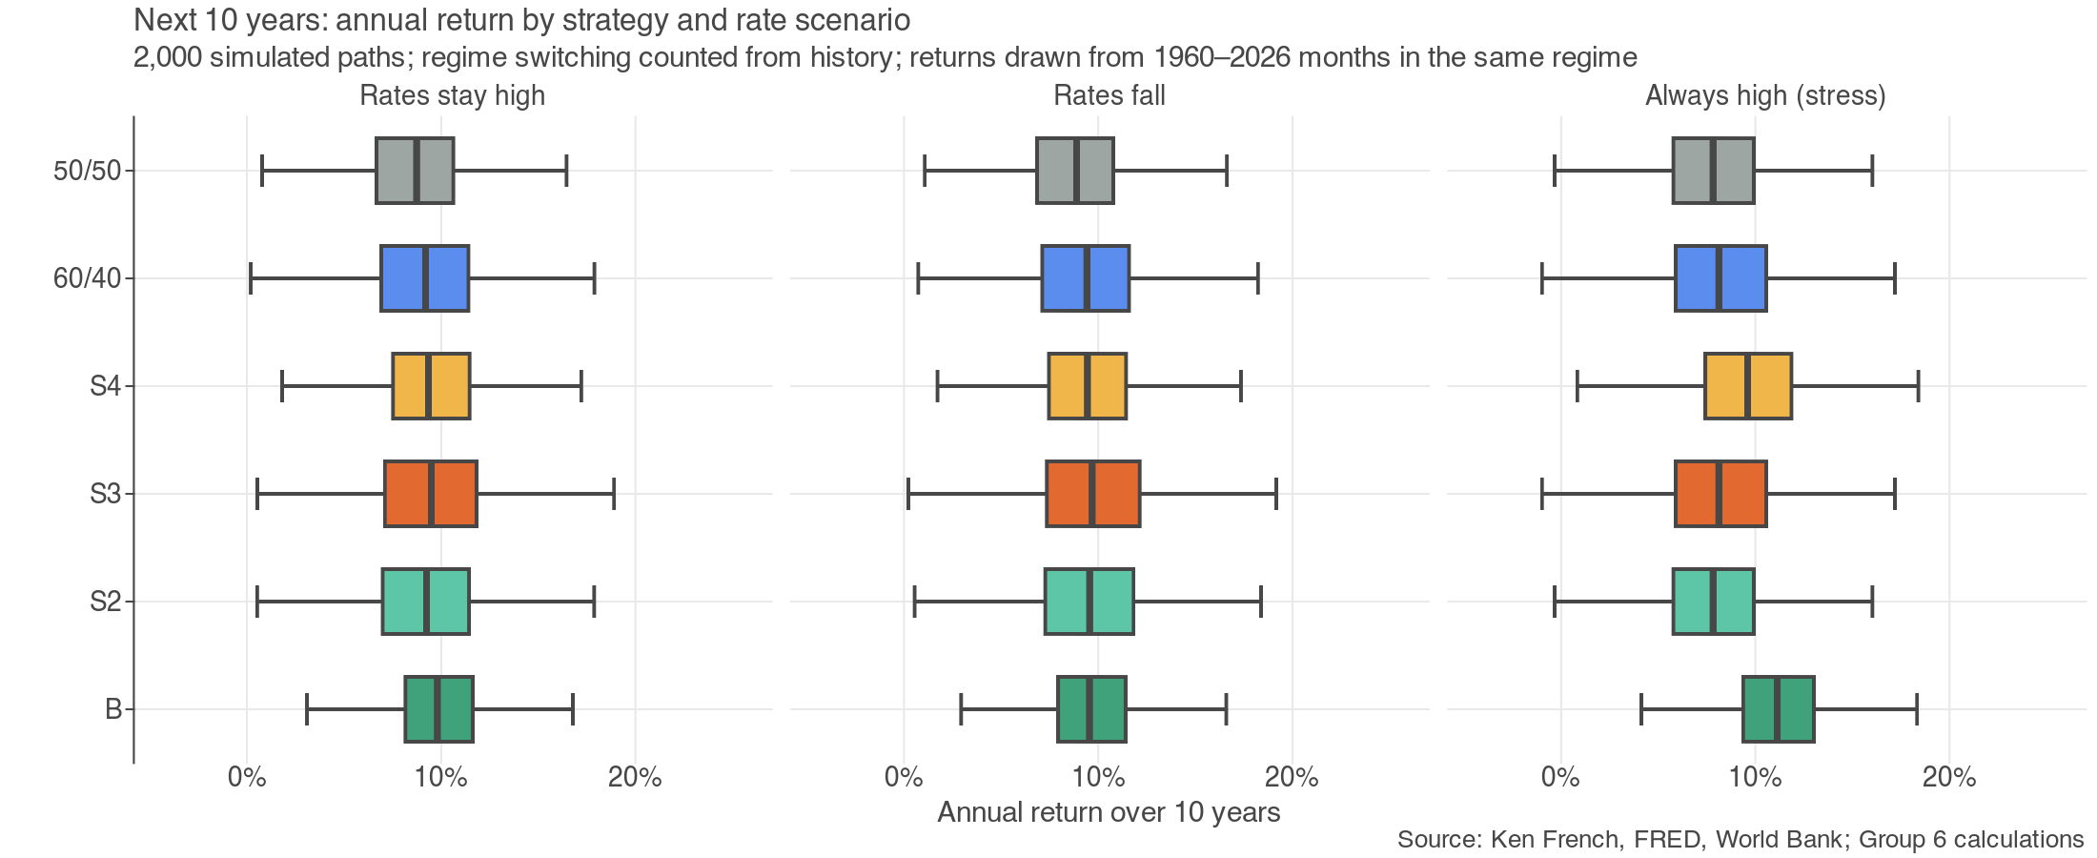
Figure 9: Distribution of 10-year annualised returns by strategy under three rate scenarios.
The benchmark has the best worst case in every scenario. If rates stay high, 50/50 earns less than 60/40 (8.7% vs 9.2%) with a similar worst case, so cutting stocks for bonds costs return without buying much safety. If rates never fall, every stock/bond mix does worse, and the diversified portfolios (B, S4) hold up best.

7 Verdict and Central Message
- H0 vs H1: on the paper's sample, H0 is rejected (4 of 6 tests; regression t = -2.06, paper −2.2). Split in time, the direction holds in both 1926–1995 and 1996–2026, but significance does not.
- H2 (Sharpe ratio): rejected; the Sharpe ratio halves after higher-rate months (0.59 vs 0.28).
- H3 (deficit offset): rejected; a big deficit does not protect stocks when rates are high.
- Strategies: cutting stocks for bonds when rates are high (S1, S2, S3, 50/50) did not beat simple diversification out of sample; shifting the diversifiers toward gold and momentum (S4) did, though not significantly.
Central message: "Being in the middle doesn't mean retreating to risk-free. Hold around 60% in stocks and, when rates are high, diversify the rest with gold and momentum rather than bonds alone." High rates do shrink the equity premium, as the paper says, but the effect is too noisy to time the stock share. What a higher-rate world changes is which assets protect a portfolio, not whether to own stocks.

8 Performance Measures and Evaluation Metrics
Measure | Definition | Why we use it
Return above cash | Return minus the T-bill return (monthly, annualised ×12) | The paper's measure of the risk premium
Sharpe ratio | Mean excess return ÷ its standard deviation, annualised ×√12 | Reward per unit of risk (H2, all strategies)
Alpha, beta | Intercept (annualised) and slope from regressing a strategy's monthly excess return on the benchmark B's | Return the benchmark does not explain, and exposure to it (Lecture 3)
Annual volatility, variance | Standard deviation (×√12) and variance (×12) of monthly returns | Total risk
Max drawdown | Largest peak-to-trough fall in cumulative value | Worst loss an investor would have lived through
CVaR 5% | Average loss in the worst 5% of months | Tail risk; reported for every strategy
Turnover | Sum of absolute weight changes, per year | Trading activity; each unit costs 10 bps
Certainty equivalent | Mean excess return − ½ A σ², A = 3 | Picks a stock share where the Sharpe ratio cannot (Lecture 1)
Newey-West t-statistic | t-statistic robust to autocorrelation | Rate levels persist, so the ordinary t overstates significance
Out-of-sample R² | 1 − SSE(model) / SSE(training-sample mean) | Does the rate signal forecast? (Campbell and Thompson 2008)
Validation Sharpe | Sharpe ratio on a walk-forward validation window inside the in-sample period | Tunes S4's η without using the test period

9 Limitations and Next Steps
- Proxies, not the paper's data. Treasury and credit returns are built from yields, and momentum stands in for hedge-fund cash-plus indices; PDP is long-only, so it is closer to equity than a true cash-plus fund.
- Short investable history. The out-of-sample period is under six years and dominated by a large-company rally and a gold rally; S4's edge depends heavily on the second.
- One split. The ETF backtest has a single in-sample / out-of-sample split. With more history, a rolling walk-forward of every strategy, not only of S4's η, would be stronger.
- Regime thirds use the whole sample. The good / middle / bad split describes history; it is not a trading rule.
- Gold before 1971 was fixed at $35, so its early diversification is overstated as zero correlation.
- Next steps: test real cash-plus funds (DBMF, market-neutral) as their history grows; add valuation (CAPE) to the rate rule; check other countries, as the Lecture 4 checklist asks of any new signal.

References
Maloney, T. (2024). Honey, the Fed Shrunk the Equity Premium: Asset Allocation in a Higher-Rate World. The Journal of Portfolio Management, 50(6).
Pun, C. S., Wang, T., & Yan, Z. Data-Driven Distributionally Robust CVaR Portfolio Optimization under Regime-Switching Ambiguity Set. SSRN 4378930.
Campbell, J., & Thompson, S. (2008). Predicting Excess Stock Returns Out of Sample: Can Anything Beat the Historical Average? Review of Financial Studies, 21(4).
Asvanunt, A., & Richardson, S. (2017). The Credit Risk Premium. The Journal of Fixed Income, 26(3).
DeMiguel, V., Garlappi, L., & Uppal, R. (2009). Optimal Versus Naive Diversification. Review of Financial Studies, 22(5).
French, K. R. Data Library. mba.tuck.dartmouth.edu/pages/faculty/ken.french/data_library.html.
Shiller, R. J. Online Data. shillerdata.com. · Damodaran, A. Historical Returns. pages.stern.nyu.edu/~adamodar. · World Bank Commodity Price Data (Pink Sheet). · Federal Reserve Bank of St. Louis, FRED.
Liu, P. QF600 Asset Pricing lecture notes, Weeks 1–6, SMU, 2026.

Annex A Datasets
Every file the notebook uses, from 02 - Dataset Metadata Group 6.md. Script-downloaded files are rebuilt by notebook §1.
File | Description | Source | Rows | Cols | Period
damodaran_annual.csv | Annual returns: S&P 500, small cap, 3M T-bill, 10Y T-bond, Baa corporate, real estate, gold (parsed) | Aswath Damodaran (NYU Stern) | 98 | 8 | 1928-01-01 → 2025-01-01
damodaran_histretSP.xls | Damodaran raw workbook | Aswath Damodaran (NYU Stern) | 143 | 7 | 1890-01-01 → 2025-01-01
etf_prices_daily.csv | ETF adjusted closes: SPY, IEF, TLT, HYG, VNQ, PSP, GLD, RSP | Yahoo Finance via `yfinance` | 6,248 | 10 | 2002-01-02 → 2026-10-30
ff3_monthly.csv | Fama-French 3 factors: Mkt-RF, SMB, HML, RF (% per month) | Ken French Data Library | 1,203 | 5 | 1926-07-01 → 2026-09-01
ff_umd_monthly.csv | Momentum factor UMD (% per month) | Ken French Data Library | 1,197 | 2 | 1927-01-01 → 2026-09-01
fred_aaa_baa.csv | Moody's seasoned Aaa and Baa corporate bond yields (%) | FRED | 1,293 | 3 | 1919-01-01 → 2026-09-01
fred_cpi.csv | CPI, all urban consumers, not seasonally adjusted | FRED | 1,364 | 2 | 1913-01-01 → 2026-09-01
fred_deficit_gdp.csv | Federal surplus or deficit (−), % of GDP, fiscal year | FRED | 97 | 2 | 1929-01-01 → 2025-01-01
fred_dgs3mo.csv | 3-month Treasury constant-maturity yield (annualised %) | FRED | 11,290 | 3 | 1981-09-01 → 2026-10-29
fred_gdp.csv | Nominal GDP, $ billions | FRED | 97 | 2 | 1929-01-01 → 2025-01-01
fred_gs10.csv | 10-year Treasury constant-maturity yield (%) | FRED | 882 | 2 | 1953-04-01 → 2026-09-01
fred_interest_gdp.csv | Federal interest outlays, % of GDP (for primary deficit) | FRED | 86 | 2 | 1940-01-01 → 2025-01-01
fred_mts_deficit.csv | Monthly Treasury statement surplus or deficit (−), $ millions | FRED | 552 | 2 | 1980-10-01 → 2026-09-01
fred_tb3ms.csv | 3-month T-bill rate, secondary market (annualised %) | FRED | 1,113 | 3 | 1934-01-01 → 2026-09-01
shiller_ie_data.xls | Shiller raw workbook | Robert Shiller | 1,878 | 20 | 1871-01-01 → 2026-09-01
shiller_monthly.csv | S&P composite P, D, E, CPI, real EPS, CAPE (parsed from ie_data.xls) | Robert Shiller | 1,870 | 10 | 1871-01-01 → 2026-10-01
wb_cmo_monthly.xlsx | World Bank Pink Sheet raw workbook | World Bank Commodity Price Data (Pink Sheet) | 808 | 17 | — → —
wb_gold_monthly.csv | Gold price, $/troy oz (parsed from the Pink Sheet) | World Bank Commodity Price Data (Pink Sheet) | 801 | 2 | 1960-01-01 → 2026-09-01

Annex B Additional Results
Next month (1M) | In-sample: lower / higher | Gap (t) | Out-of-sample: lower / higher | Gap (t)
M1 Median | 10.7% / 5.2% | -5.5% (-1.14) | 9.2% / 8.6% | -0.5% (-0.10)
M2 Trailing | 12.6% / 4.7% | -7.9% (-1.63) | 9.8% / 8.0% | -1.8% (-0.30)
M3 Centred | 13.7% / 1.8% | -11.9% (-2.32) | 15.7% / 1.5% | -14.1% (-2.42)
H0 vs H1 split in time (§3.4), one-month horizon. Annualised return above cash; Newey-West t in brackets.
Exhibit 3, other horizons | After lower | After higher
Treasuries · 1M | 2.2% | 1.1%
Treasuries · 36M | 1.7% | 1.8%
IG credit · 1M | 4.0% | 0.2%
IG credit · 36M | 3.1% | 1.0%
Momentum · 1M | 3.0% | 10.9%
Momentum · 36M | 5.1% | 9.1%
Annualised return above cash, Jul 1926 – Dec 2023, average of the three rules.

AI Assistance Statement
Prepared with the assistance of Claude (Anthropic) for code, data pipelines and drafting. All results were run from the group's notebook and checked by the group.

